COMPUTER SCIENCE PROJECT  
2014-2015

SRI KUMARAN CHILDREN’S HOME C.B.S.E

IMAGE FORMATION  
IN LENS AND MIRROR

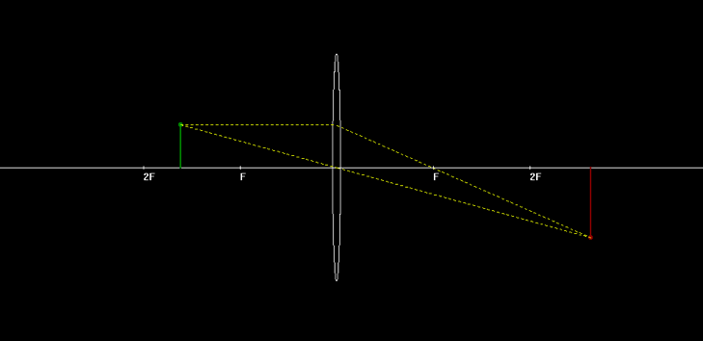

AKHIL U   
ANSUMAN PALO

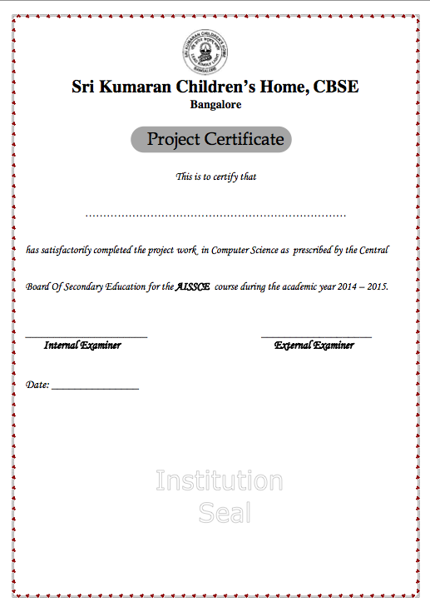

ACKNOWLEDGEMENTS

We would like to thank our Computer Science teachers, Smitha ma’am and Kavita ma’am, without whose invaluable knowledge and support, completing this project would have been an arduous task. We would also like to express our gratitude towards the school staff and principal for providing us the opportunity to access the laboratory.

INDEX

SYNOPSIS

The project is based on the reflection and refraction by different types of spherical mirrors and lenses respectively.

It uses a graphical representation of the image formation taking into account the necessary values like focal length, object distance and the object height to accurately calculate and plot the image.

The program uses an interactive interface allowing the user to:

* Feed values from a text window which opens a graphics window with required data
* Manipulate previous values in graphics window which gets refreshed
* Save the current data (in a data file).
* Open previously saved data.

REASONS FOR PROJECT

The project provides a graphical approach to the topic which is required for a better understanding. Many cases can be handled more accurately with the tool. Often visualisation of the cocept of image formation in ray optics can be quite an ordeal. This tool provides a medium to comprehend these concepts through pictorial representation.

SYSTEM REQUIREMENTS

Requirements for program execution:

* + OS – Windows XP/ Appil or higher
  + RAM – 1GB or higher

Requirements for Compilation and debugging:

* + OS – Windows XP/ Appil or higher
  + RAM – 1GB or higher
  + C++ compiler with BGI graphics support (e.g. Bloodshed Dev C++, Visual Studio)

CLASS DIAGRAM

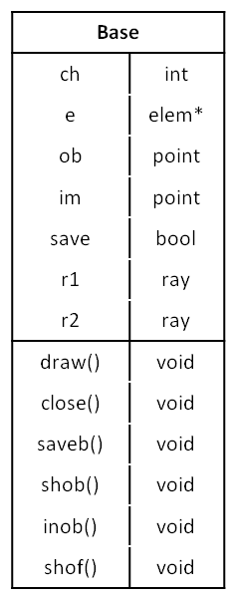

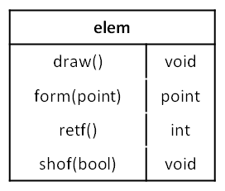

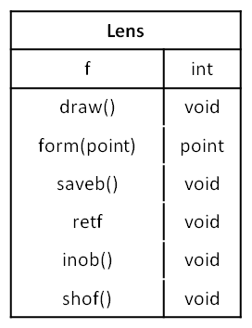

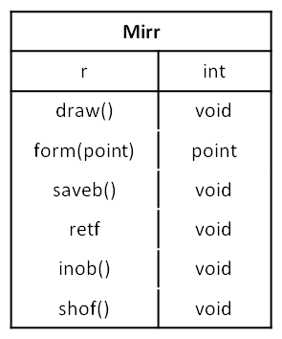

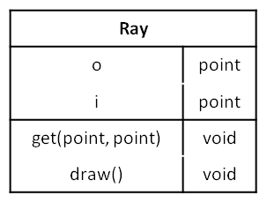

STANDARD HEADER FILES

iostream

fstream

math.h

FLOWCHART

main()

Displays menu

nwindow:

Create new

swindow:

Open from saved file

Base:Constructor

Base:draw

initwindow

disp

closegraph

Draw lens/mirror

Draw rays

Draw obj, img

Get img using form

Reset:

Remove saved data

Graphics Window

Shift object

Change object height

Change focal length

Save current state

(savebase)

Exit

Based on user selection

SOURCE CODE

SCREENSHOTS

First menu:  
  
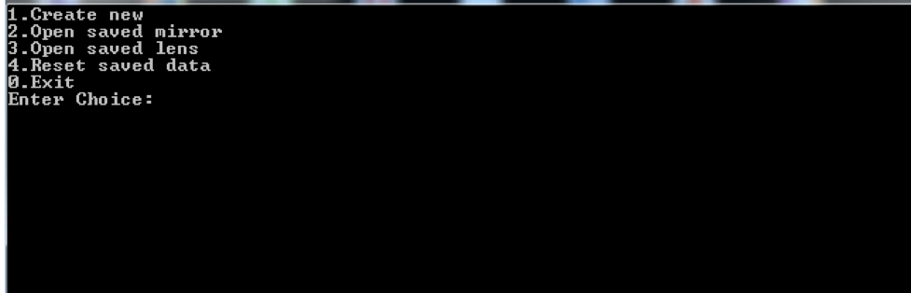

Opening a record from saved list:  
  
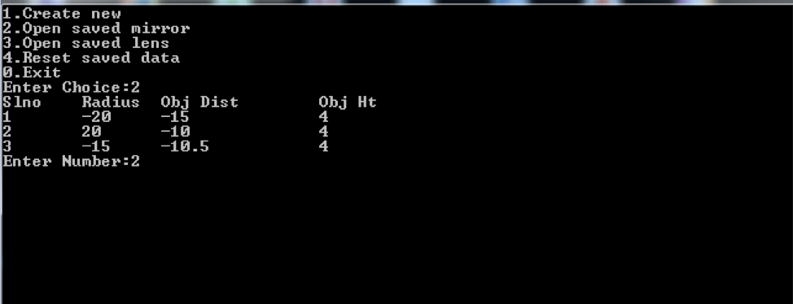

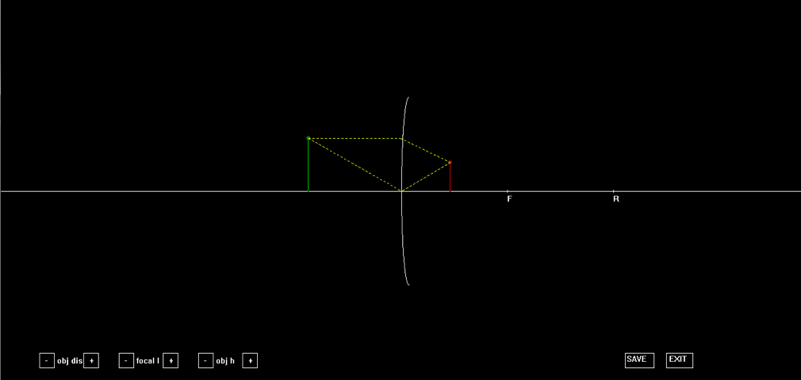

Saving a file :

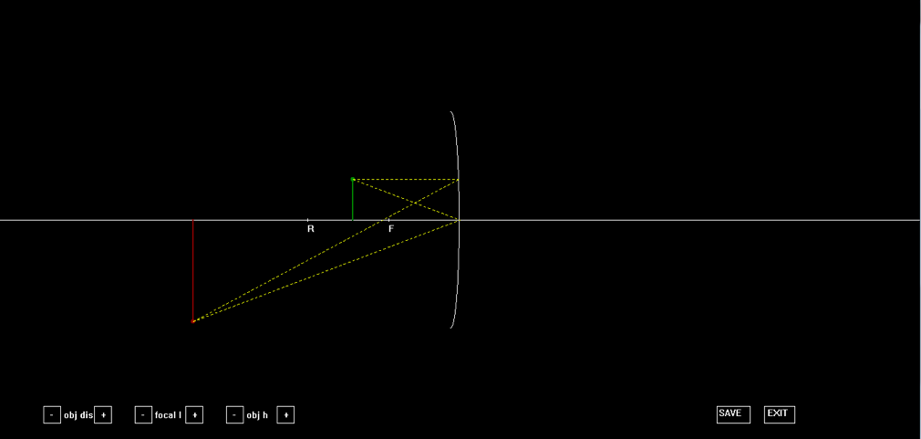

click on the “SAVE” button  
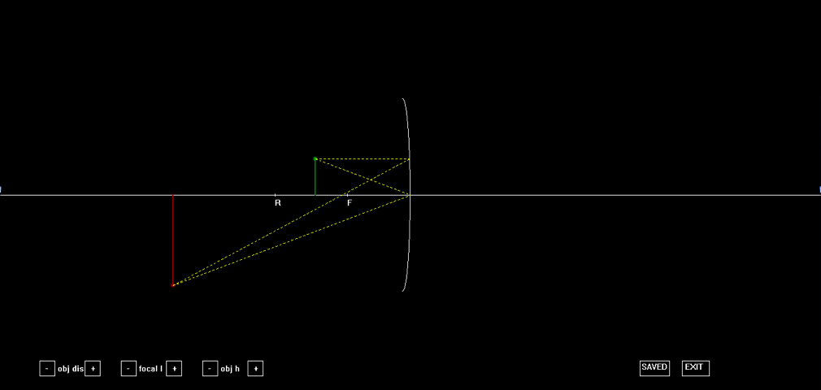

Modifications can be made with the help of the buttons:

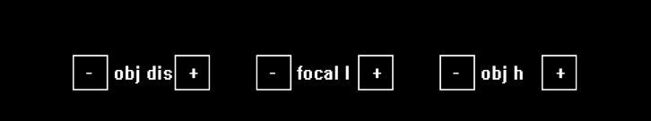

SCOPE FOR IMPROVEMENT

The project is a basic version of the intended result and requires a lot of upgrades, patches and debugging to include more cases, add more features and improve its efficiency.

We find the following to be major areas which require attention:

Known Bugs and errors:

* Certain cases (e.g. image at infinity) cannot be displayed appropriately.
* Numeric details (distance, height, focal length) are not displayed in the graphics window correctly (feature removed).

Areas of Improvement:

* Upgrade to include comparison of two or more cases simultaneously.
* Improve the save function to remove duplicates and include a delete option. This can be done by upgrading to databases from flat files.
* Make the interface more user-friendly, e.g. by making the graphics more dynamic, adding more features like control of curvature, number of rays, etc.

Cover(done),certificate,acknowledgements,index,synopsis(done),reason for project(done),system requirements(done), class diagrams with function description(func desc left), standard header files(done), flow chart(done), source code(back to back), screenshots, scope for improvement(done), bibliography, webliography.